**Python Data Type: List**

Name: Krzysztof Krasa

Album no. : 163046

Group: WAW_2023_L_N_I_INF7_C4

Student email: wwx20855@student.warszawa.merito.pl

GitHub link:   
https://github.com/KeyKrejsa/Podstawy_Programowania  
  
1.

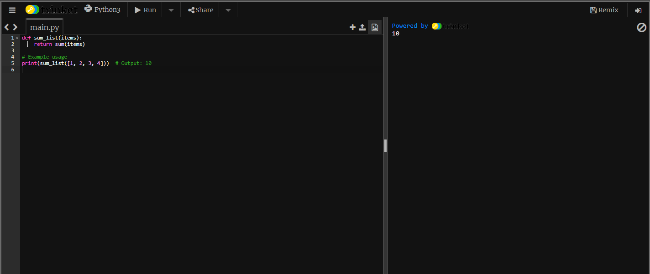

2.  
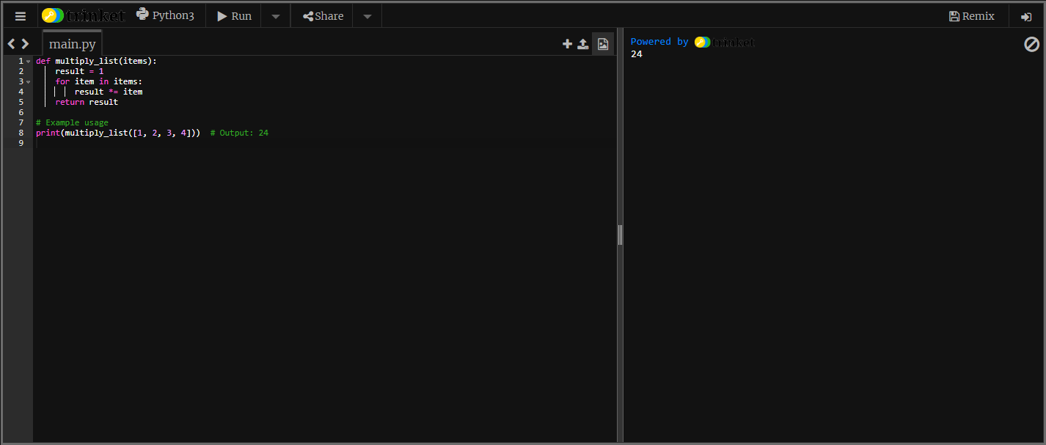  
  
3.   
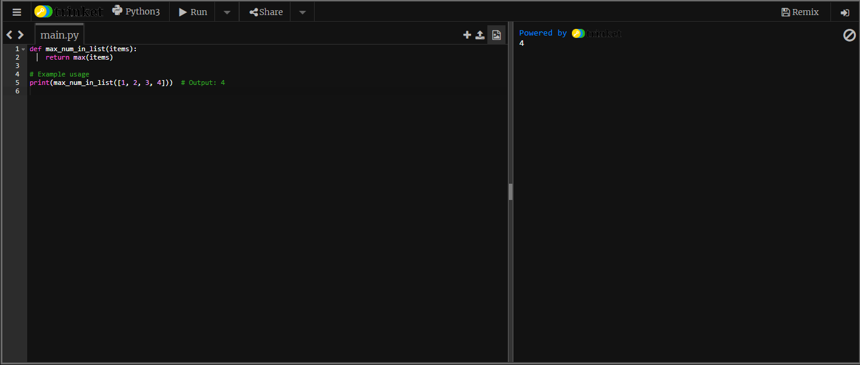  
  
4.  
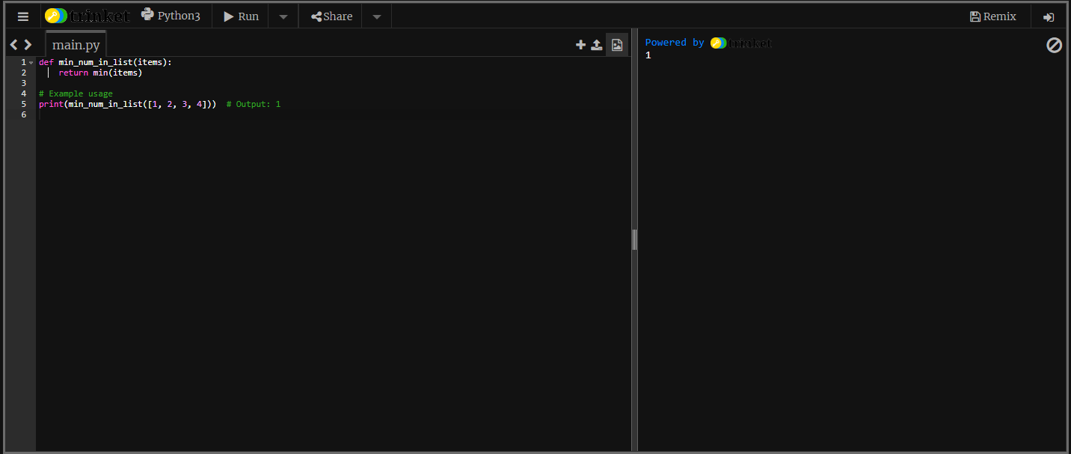  
  
5.  
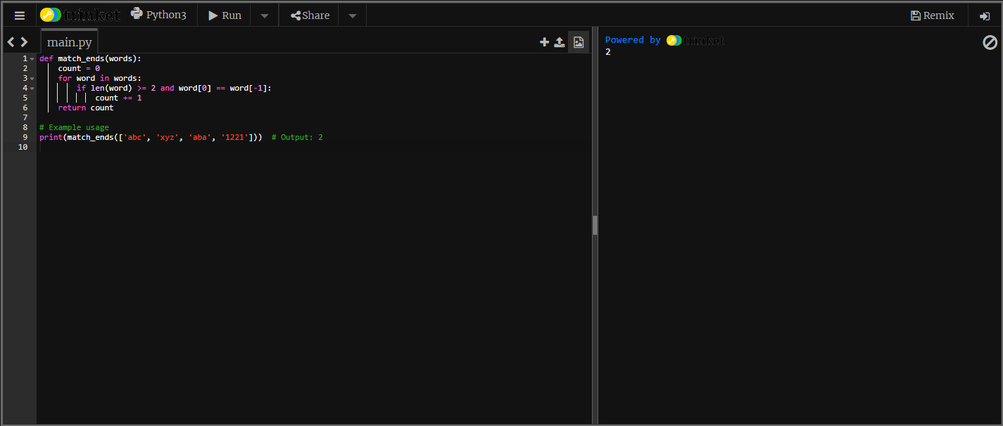  
  
6.  
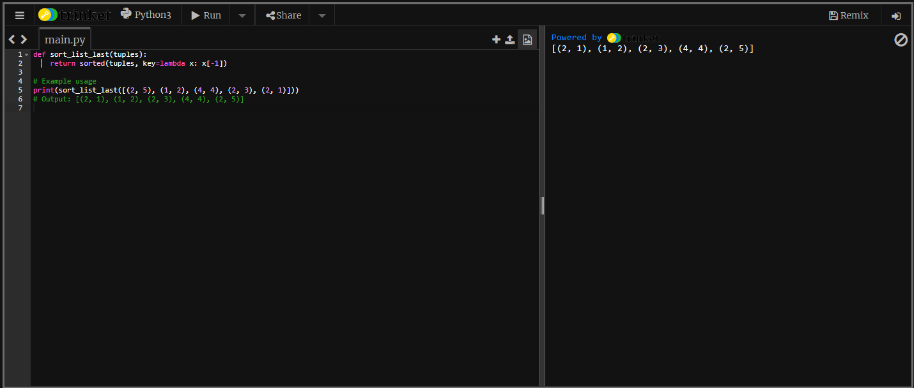  
  
  
  
  
  
  
  
  
  
  
7.  
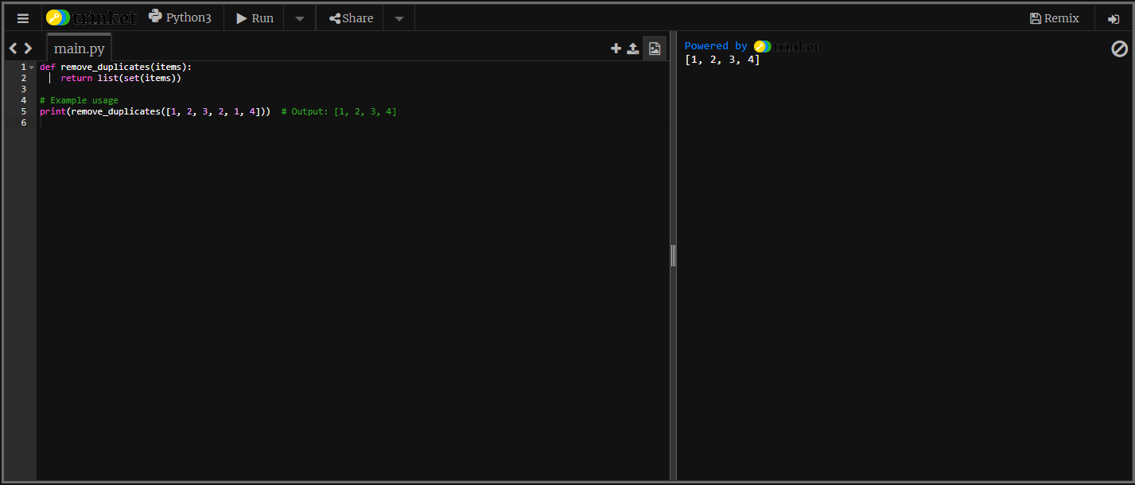  
  
8.  
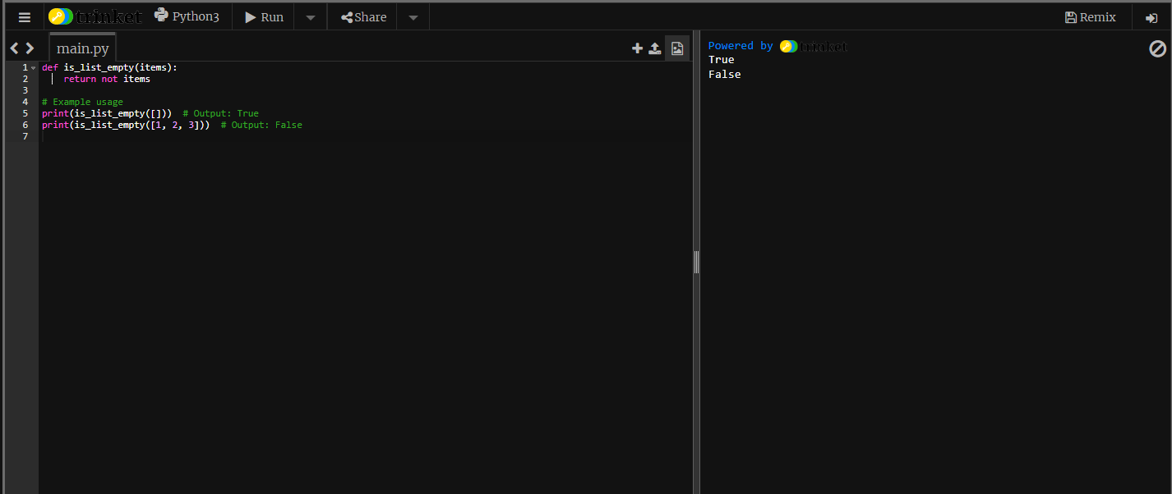  
  
9.  
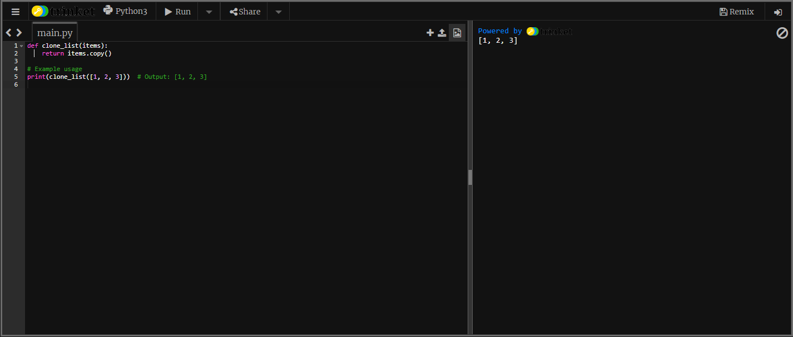  
  
10.  
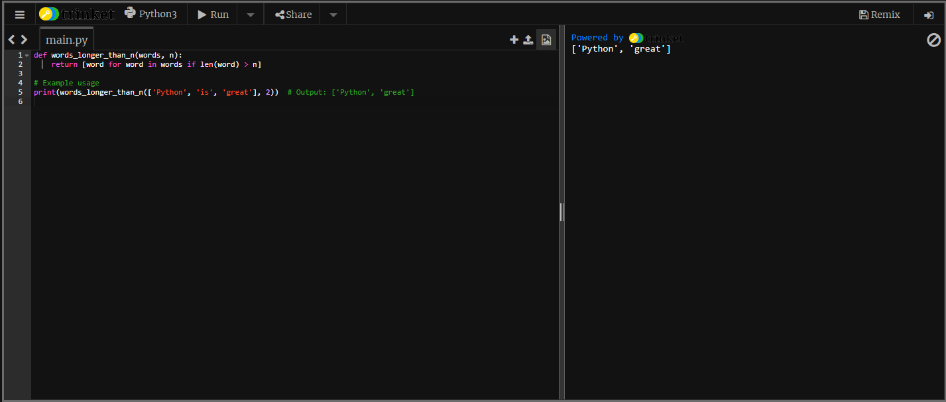  
  
11.  
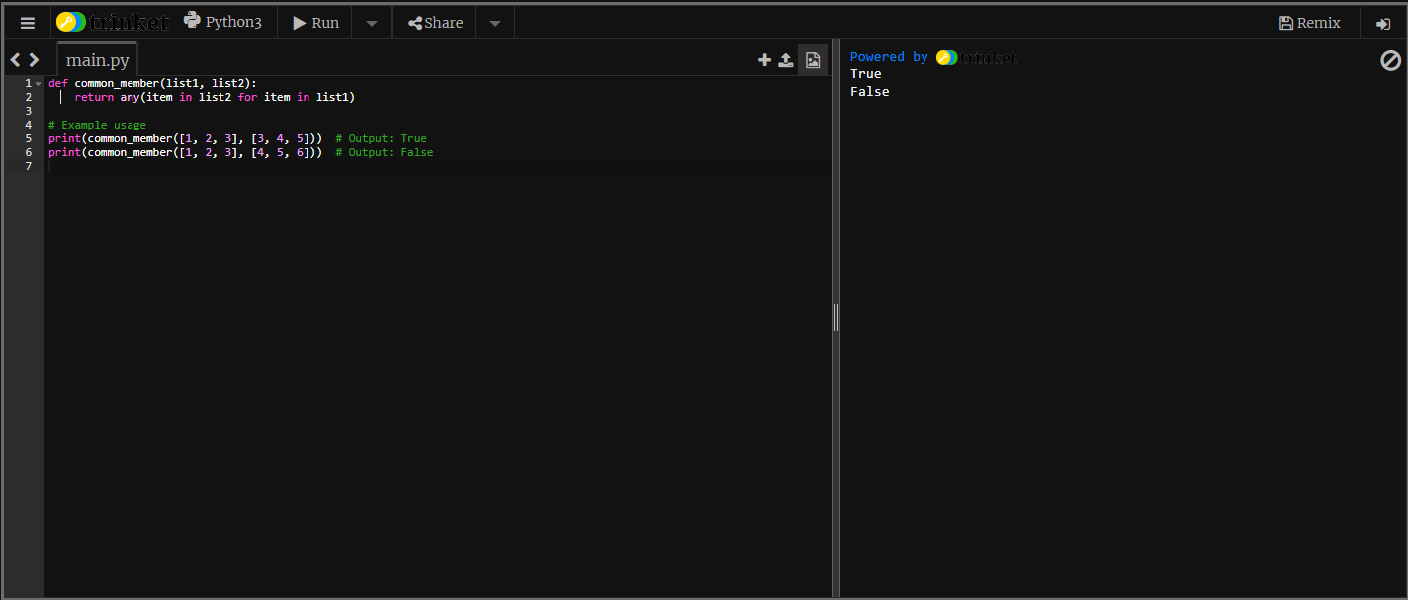  
  
  
  
  
  
  
  
  
  
  
12.  
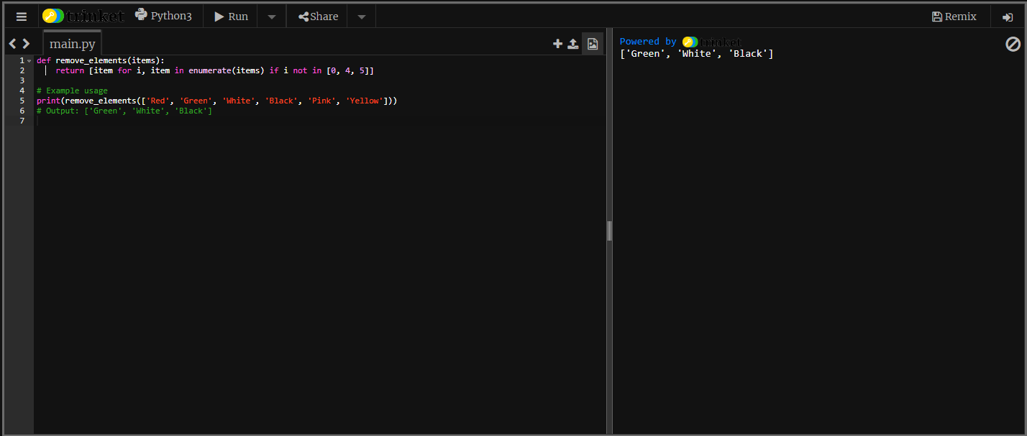  
  
13.  
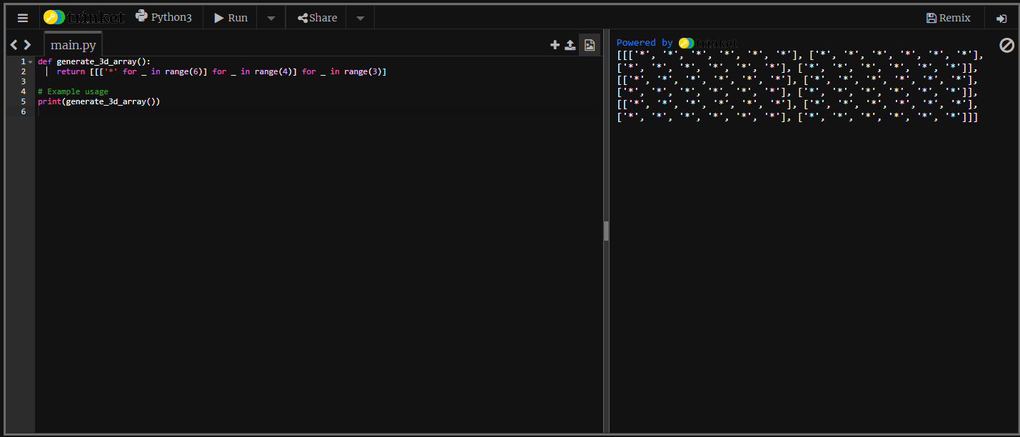  
  
14.  
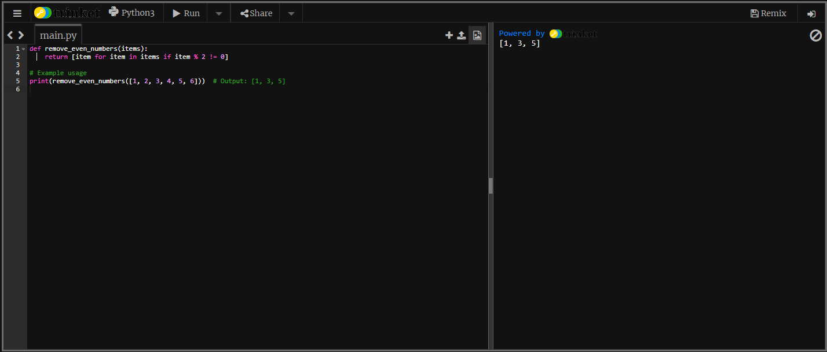  
  
15.  
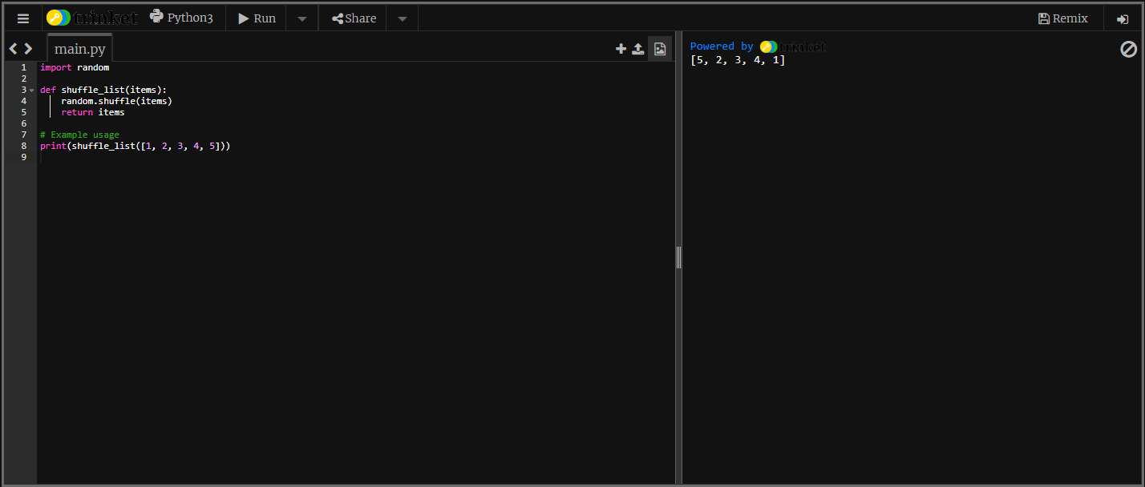  
  
16.  
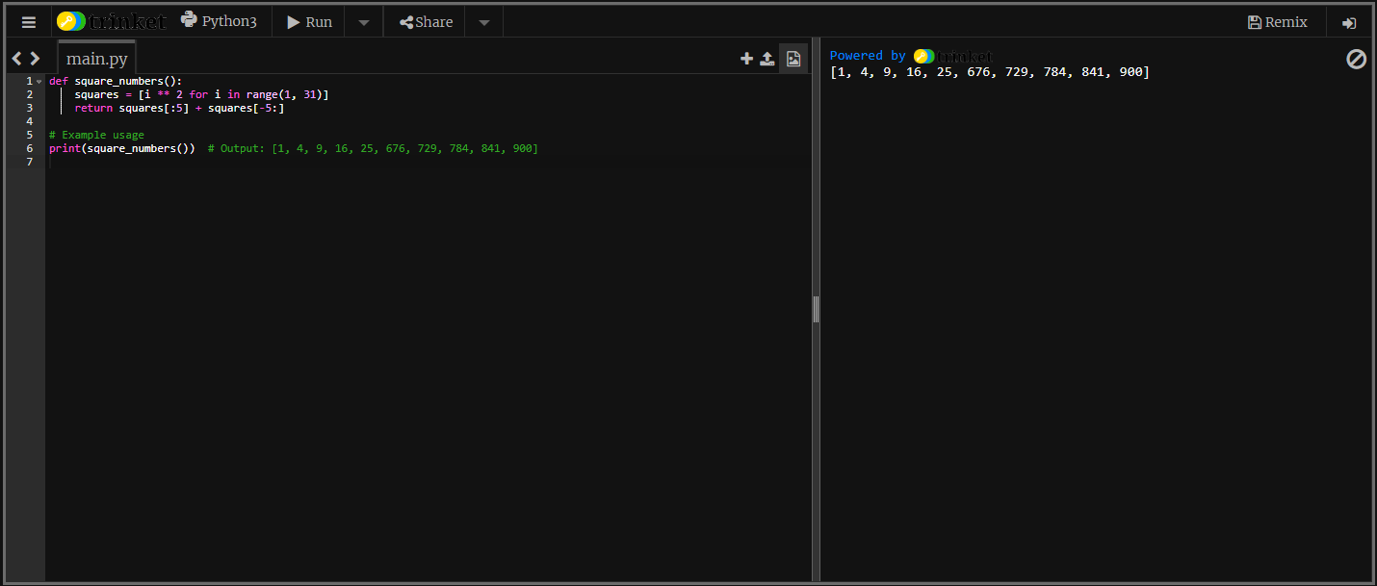  
  
17.  
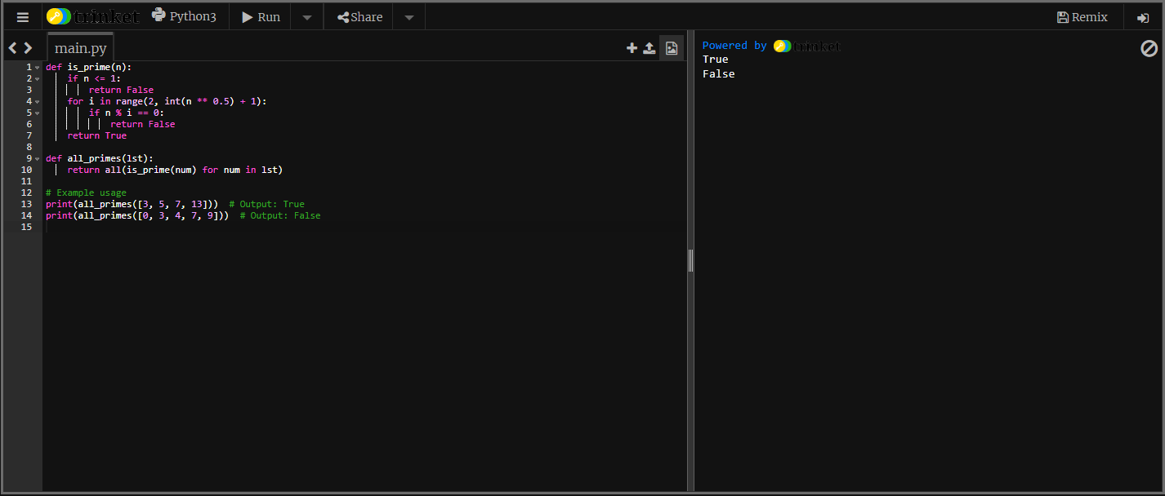  
  
18.  
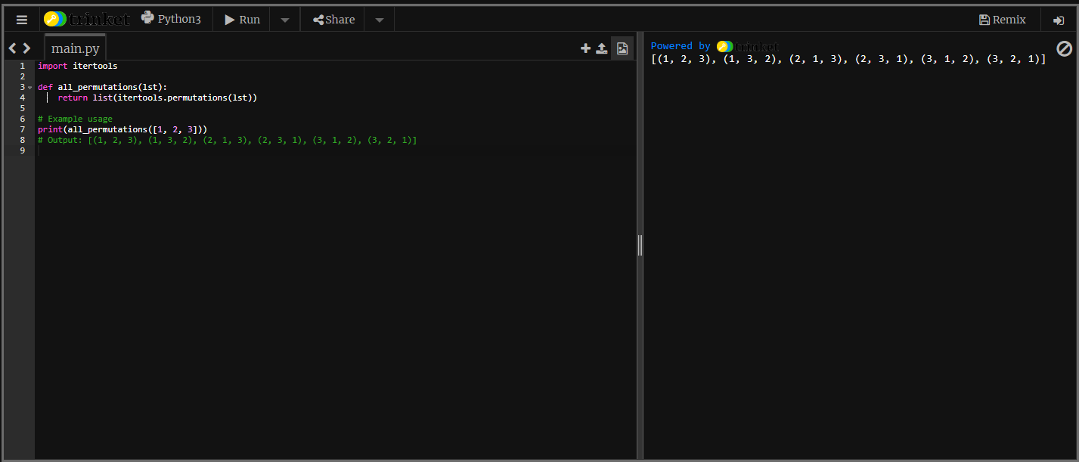  
  
19.  
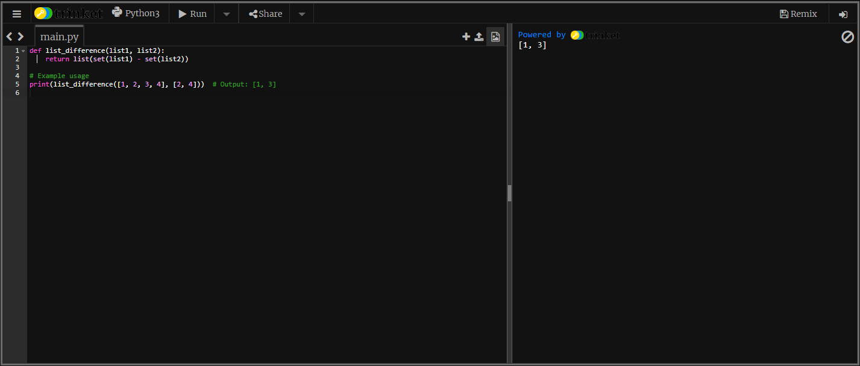  
  
20.  
